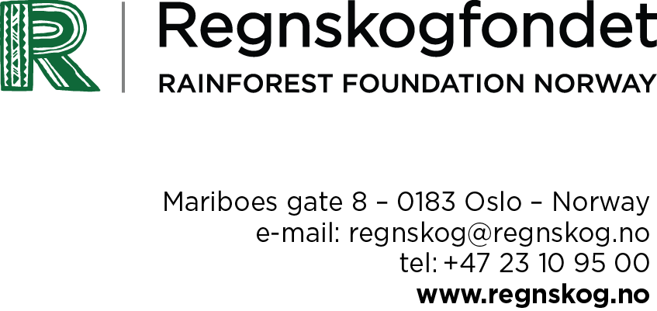
To: Donor Participants in FCPF
REDD Country Participants in FCPF
CSO Observers

Dato 30.06.2015
Input on DRCs R-package

Rainforest Foundation Norway would like to share its views about the DRCs R-package:

Input on DRCs R-package:

Rainforest Foundation Norway suggests the following points to be included in the resolution about DRCs R-package to be approved at the 19th Participants Committee Meeting:

What are remaining needs and gaps in the DRCs readiness-work and what must be addressed before starting giving out money from the Carbon Fund:

1. Substantial progress at the national level. Specifically, this must be implemented:
a. The Indigenous Law must be adopted.
b. The law on forest concessions to local communities must be implemented (community forests).
c. Work on land reform and land use planning reform must be well underway.

2. Consultations: Better involvement of local communities and the provincial authorities, improvement of the consultation processes and the communications in Maï-Nombe.

3. A functioning national REDD-control unit.

4. Transparency about what the government has spent readiness funds for.

Introduction

Securing indigenous peoples’ land and resource rights is the most efficient way of protecting rainforests sustainably. DRC’s REDD+ framework strategy has taken some positive steps in this direction. However, concrete, consistent and coordinated work on the strategy’s fundamental pillars, especially on tenure and land use planning, will be central in bringing these commitments into practice.

1a) A law on indigenous peoples’ rights

Indigenous peoples’ organizations, in collaboration with a group of parliamentarians, have developed a draft bill on indigenous Pygmy peoples’ rights. The text is the result of more than four years of work. National and international experts have given their inputs. Indigenous peoples have been consulted in their environment, with a view to reflect the contextual diversity lived by indigenous peoples throughout the country. The text was submitted to the National Assembly in July, 2014.

In March 2015, on behalf of the Presidency and the Government, the DRC Minister of Environment and Sustainable Development officially expressed his support to the draft bill. He committed himself to support all efforts pursued by the articles enshrined in the text, and to work for securing indigenous peoples’ land and resource rights. The draft bill is to be discussed at the National Assembly during the parliamentary session ending June, 2015.

The adoption of this new legislation would be a milestone for the protection of indigenous peoples’ rights, set a clear baseline on the issue for tenure reforms, and also materialize the potential indigenous peoples’ traditional management of the rainforests represent for REDD+ in DRC.

1b) Local communities’ forest concessions

The DRC Government adopted a decree on local communities’ forest concessions in August 2014. This is an important step towards the formal recognition of forest-dependent communities’ rights on their customary lands and forests and their right to manage the latter. In order to allow the full implementation of this decree, another regulation should be adopted. The text of this regulation is available since 2012. It is a consensual text resulting from broad consultations and extensive field work.

The DRC Government should adopt the consensual text of this second regulation without further delay. The DRC Government and international partners must take all appropriate measures to ensure failures made in other countries won’t be replicated, and that community forests won’t be ill-funded and become marginal in sustainable rainforest management.

With the view of giving forest-dependent peoples the possibility to fulfil the rights recognized in the two regulations, and manage the challenges they may encounter in their implementation, DRC’s international partners should commit themselves to secure substantial support, both technically and financially, to the work on local communities’ forest concessions in DRC.

A common objective of the Government and international partners should be the development of community forestry as a major sustainable management model in the country’s land use planning.

1c) Tenure reform and land use planning

National tenure reform and land use planning should be given high priority by both the DRC Government and international partners. When reforming tenure legislation, indigenous peoples’ land and access rights must be duly recognized and protected, and the diversity of the contexts indigenous peoples live throughout DRC must be taken into account. As reflected in the national REDD+ framework strategy, participatory mapping should be used widely and with due respect to the local contexts, to identify customary and indigenous peoples’ rights. The information gathered through participatory mapping is both relevant for the tenure reform and land use planning.
Respecting indigenous peoples’ right to free, prior, informed consent is an obligation, which should be included in tenure legislation and sustain any decision in land use planning that may affect indigenous peoples, their lands and natural resources.

2. Maï-Ndombe

The process in Maï-Ndombe is suffering from poor participation of local communities and the provincial authorities and administrations. Also, high expectations to the REDD+ process is creating tensions locally, as people are expecting visible benefits on the ground that have not materialized.
Partly the tension can be related to the very poor development of communication systems on REDD+ in general in DRC, and inconsistent communication in Maï-Ndombe specifically.
In addition, the consultation processes on who should be local representatives with local communities have been conducted within a very limited time, thereby hampering the necessary analysis and understanding of local contexts, and eventually the legitimacy and ownership of these processes.

3. Governance structure

The REDD+ governance structure has encountered serious challenges these past years. The National REDD+ Committee, which should be the governing and decision-making body in REDD+, has not functioned properly, and has not given the opportunity to indigenous peoples’ representatives to play their role. The frequent use of non-representative consultants where NGOs could have been used, and short deadlines for input to important documents, is hampering the possibility to have good processes.

The DRC Government must put in place a governing body that guarantees a meaningful participation of indigenous peoples that respects their right to free, prior, informed consent in decision-making.

4. Transparency

Civil society has asked for transparency regarding the use Readiness preparatory funds, i.e. 3,6 million USD, and the additional preparatory funding of 5,2 million USD, asking for financial reports (with details) to be published.

For any questions, please contact:
Monica Camacho (present at the PC-meeting), monica@rainforest.no, + 47 41009167
Gunnell Sandanger, gunnell@rainforest.no, +47 40247025
Gøril L. Andreassen, goril@rainforest.no, + 47 99 56 26 69

